~UNIT ONE~
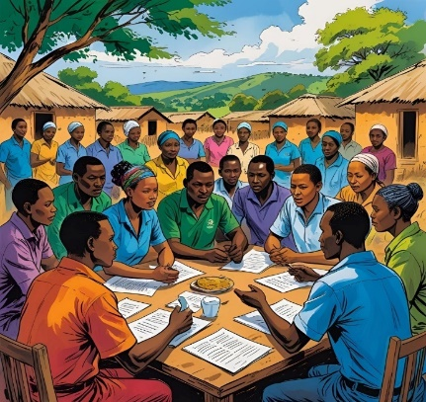

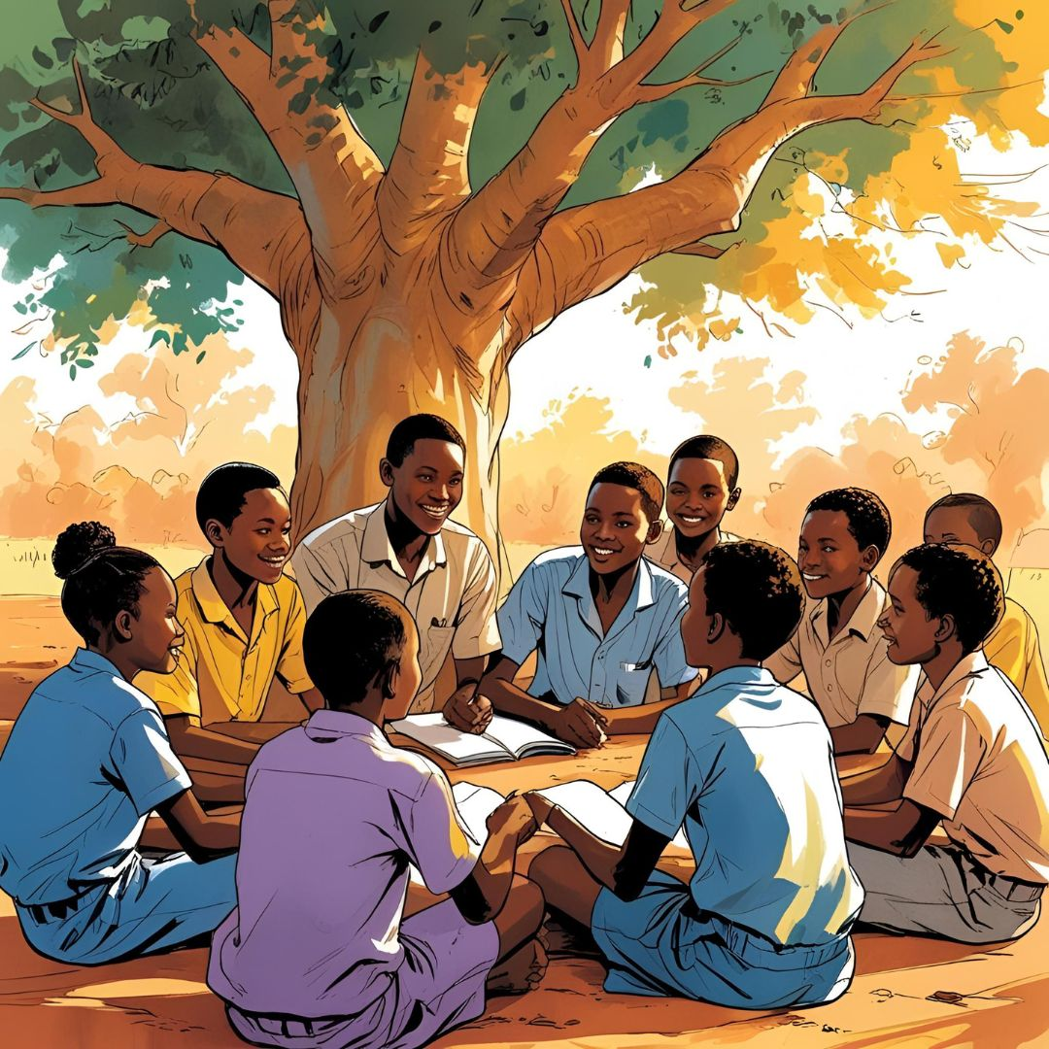

■
PRE-READING

- Find words in the word string. The paragraph number is given in the brackets.

- r a f f o r d i s d r t s u p p o r t i v e s d s c h o l a r s h i p (1)
- d n v o l u n t e e r u n i f o r m s t g e r y t a l l o w a n c e (1)
- l t u t o r i n g d l o c a l z c o n f i d e n c e e f g h t r e l o u (2)
- i n c o m e c v o c a t i o n a l f r e h d o c u m e n t s p o s t e r (3)
- l c o m m u n i t y r e x p e r i e n c e r o f fi c i a l s r e w s a x (4)
- s v a l u a b l e e t g t r a d i n g r t e c h n i c a l u y t r e w m (5)
- v u l n e r a b l e s d e f f or t v s t a b l e v f g t c h a n c e (6)
- principal o j j o u r n e f g h a l i v e w o r t h w h i l e h g f e r i k (6)

- Match content (1-6) and subheadings (a-f).

Content | Subheading
1. His family tried hard to afford a bare living routine | - Vocational Training pens new Doors
2. The teacher also connected him with successful people of similar backgrounds. | - Breaking the Cycle of Poverty
3. Through this training small amounts by typing documents and creating posters for local businesses. | - A Difficult Beginning
4. These efforts showed Kamau that his community believed in him. | - Returning the Favor to the Community
5. An international trading company that exported Kenyan tea to Europe offered him a part-time job. | - Community Support Makes a Difference
6. He volunteers with an NGO supporting students from vulnerable classes and often speaks at community events. | - The Role of a Caring teacher

- Without reading in detail, compare the sentences below with the text and identify the differences. Rewrite the different parts.

- The scholarship covered his uniform, books, three full meals and bus fare.
- Mr. Omondi didn’t stop at just getting Kamau back into work.
- Kamau enrolled in a computer course which was in high demandin villages.
- A local charity donated a motorbike for him to ride to school.
- Mr. Omondi, now a school principal, often invites him to charity events.
■■
to afford: to have enough money to buy, or pay for something

bare: very simple, basic

dedication: strong positive feeling to help someone or group or do meaningful things

allowance:
a sum of money paid regularly to a person for expenses

had fallen behind: had not been able to continue

providing:
making a service, etc. available

administration: high management center

funding:
providing money

READING:

KAMAU’S LIFE JOURNEY FROM POVERTY TO SUCCESS

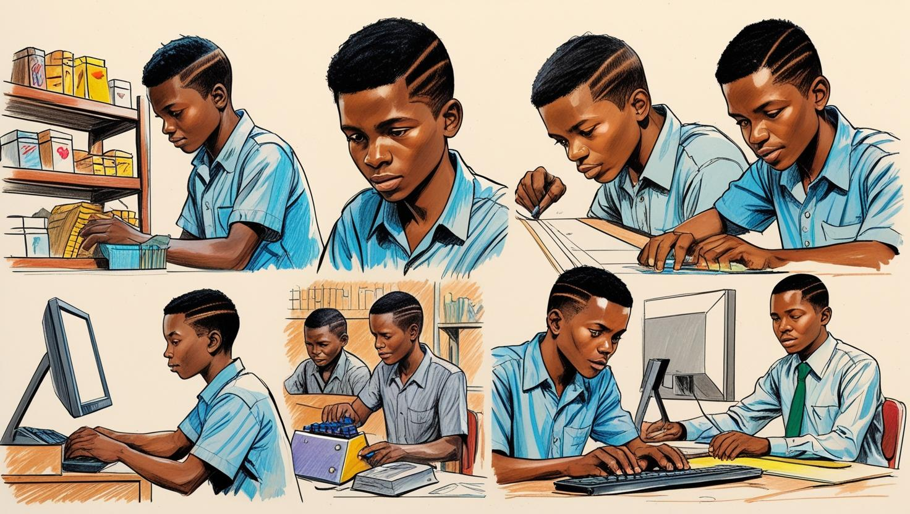

A Difficult Beginning
Kamau, a 14-year-old Kenyan teenager, knew poverty just too well. His family tried hard to afford a bare living routine; even one full meal a day, and going to school seemed like a dream. Many children in his dusty village left school early to work on farms or sell goods by the roadside. But Kamau wanted to be different and experience a real change. The start for change came when a supportive school teacher, Mr. Omondi, noticed his dedication and strong motivation during a volunteer program. Mr. Omondi encouraged Kamau to return to school and even helped him find a scholarship from the local college. The scholarship covered his uniform, books, three full meals and a small monthly allowance. With this extraordinary support, Kamau freed himself from the cycle of poverty.

The Role of a Caring Teacher
Mr. Omondi didn’t stop at just getting Kamau back into school. He spent extra hours tutoring him, because Kamau had fallen behind due to years of irregular schooling. The teacher also connected him with successful people of similar difficult backgrounds. The local educational administration played a key role by providing textbooks and funding for after-school programs. Kamau’s confidence grew as he improved in class, and he began to believe that education could be his way out of poverty.


Vocational Training Opens New Doors
faced: experienced

Fortunately:
It was a good thing that ….

enrolled: registered

contributed: provided something, or some money for help

teens:
young men or women between 13 and 19

funding:
providing money

policy: rules, laws and plans of the state

worthwhile:
valuable despite the effort, time, energy, etc

When Kamau reached high school, he faced another challenge—his family relied on his income. Fortunately, his school cooperated with a vocational training program that taught practical skills like carpentry, tailoring, and computer literacy. Kamau enrolled in a computer course which was in high demandin nearby towns. The program was funded by both the government and local NGOs and was free. Through this training, Kamau started earning small amounts by typing documents and creating posters for local businesses.

Community Support Makes a Difference
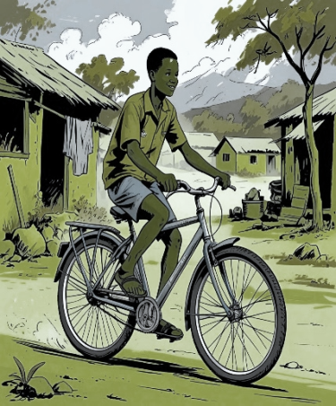
Kamau’s success wasn’t just his own—it was a result of his community’s support. Neighbors in his village contributed small amounts of money to help him pay for transportation to school on rainy days. A local charity donated a used bicycle for him to ride to school and return home without having to pay for bus tickets. Business owners in the nearest town offered part-time jobsto vocational students, giving Kamau real-world experience. Even the local officials organized meetings to encourage parents to keep their teens at school. These efforts showed Kamau that his community believed in him.

Breaking the Cycle of Poverty
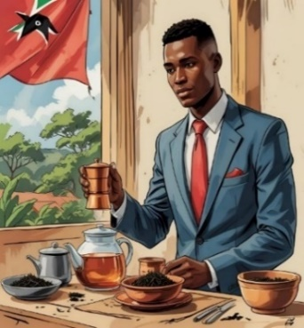
By the time Kamau was 17, he had not only completed his secondary education but also gained valuable computer skills. An International trading company that exported Kenyan Tea to Europe offered him a part-time job. The job earned him enough to support his family and saving for further studies at the same time. The vocational school connected him with a scholarship to a technical college, where he studied IT.

Returning the Favor to the Community
Today, Kamau holds a B.Sc. in IT engineering and works as a computer instructor at the same vocational school that changed his life. He volunteers with an NGO supporting students from vulnerable classes and often speaks at community events. He is invited by Mr. Omondi—now a school principal. His journey proves that education, combined with group effort and policy support, can break the chains of poverty. For Kamau, the journey was hard, but the rewards—a stable life and the chance to help others—made every struggle worthwhile.

■■■
POST-READING

- Circle the best answer (A, B, C or D). Only one answer is correct.

1. What was Kamau’s biggest challenge at the beginning of the story?
A) He didn’t have any friends.
B) He didn’t like his teacher.
C) His family couldn’t afford food or school.
D) He wanted to move to Europe.
2. Who first helped Kamau return to school?
A) a neighbor who had no children
B) a teacher named Mr. Omondi
C) a government official from the city
D) a business owner exporting tea
3. What did the scholarship Kamau received cover?
A) only his school books
B) books, meals, and a bike
C) school books, uniform, meals and allowance
D) his family’s house rent
4. What skills did the vocational training include?
A) cooking and farming
B) sports and music
C) medicine and nursing
D) carpentry, tailoring, and computer skills
5. How did the community support Kamau?
A) by donating a bicycle
B) by giving him money for transportation
C) by offering him part-time jobs
D) all of the above
6. What job did Kamau get after learning computer skills?
A) A farmer who grew tea and food products.
B) A local official who worked for educational administration.
C) A doctor who treated rural patients.
D) A tea exporter for an international company

7. Where did Kamau study IT after high school?
A) at a university in Europe
B) at home by himself
C) at a technical college with a scholarship
D) at a vocational school near his place

8. What does Kamau do now to help others?
A) He works as a computer instructor and volunteers.
B) He sells tea in a Europe exporting company.
C) He builds houses for Kenyan villagers.
D) He trains athletes for international events.
9. What lesson does Kamau’s story teach?
A) Teachers should focus on their teaching only.
B) Only rich people can succeed in life.
C) Schools are not as important as businesses.
D) Poverty can be broken with education and support.

10. What does “returning the favor” mean in the story?
A) Kamau gives money to his teacher.
C) Kamau moves to a different country.
D) Kamau forgets about his past struggles.
B) Kamau helps other poor students after his own success.

- Fill in the blank spaces with the right word from the box. There are more words than blanks.

scholarship | cycle | fortunately | literacy
opportunities | encourage | poverty | donate
secondary | donate | documents | community

- Families who live in ___________________ can’t afford food, school, health care or medicine.
- A(n) ___________________ can help poor children go to school, college or university and build a better future.
- With computer ___________________, one has good chances of finding a job.
- People who ___________________ books or uniforms help students stay in school longer.
- A strong ___________________works together to solve problems like unemployment.
- Without cooperation from people and government, the ___________________ of poverty passes from parents to their children.
- You need ___________________like your national ID to enroll in a school.
- A key standardfor developments is equal educational ___________________ for all citizens.
- The school principals should ___________________ teachers and students to join volunteer programs.
- ___________________ many teens from poor families have dedication to help others in the community.

- Look at the words in the box and insert each in the right column. Use your dictionary.

electrical training | mathematics | economics | statistics | welding
sports coaching | medicine | carpentry | biology | baking
tanning | psychology | masonry | linguistics | history
book binding | sociology | plumbing | tailoring | geography

VOCATIONAL  PROGRAM | PURE ACADEMIC  SUBJECT
electrical training | mathematics

- Use your dictionary to complete the table.

No. | VOCATIONAL PROGRAM/ ACADEMIC FIELD | SPECIALIST
1 | electrical training | electrician
2 | sports coaching
3 | tanning
4 | book binding
5 | mathematics
6 | medicine
7 | psychology
8 | sociology
9 | economics
10 | carpentry
11 | masonry
12 | plumbing
13 | statistics
14 | biology
15 | linguistics
16 | tailoring
17 | welding
18 | baking
19 | history
20 | geography
- Fill in the blanks with the words from the text. There may be more than one right answer. The first letter is given as clue.
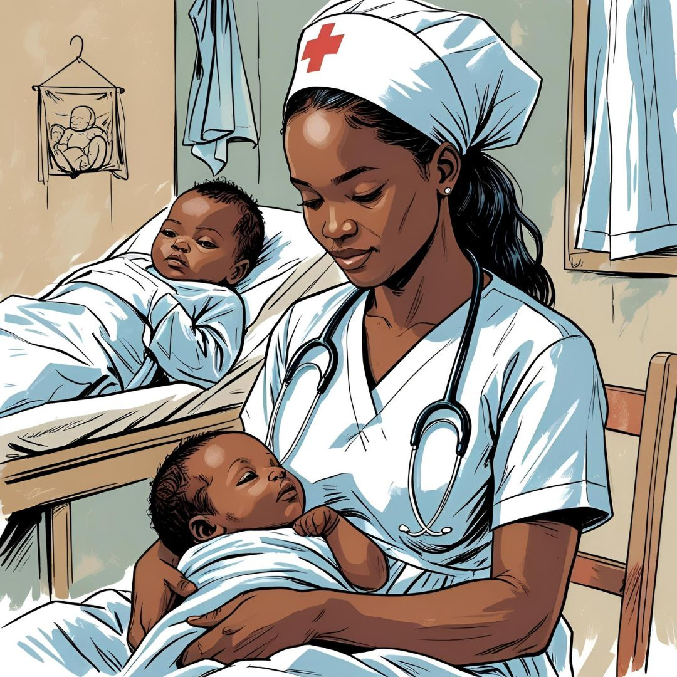
Grace, a 15-year-old girl from rural Uganda, grew up in poverty. Many girls in her village married young, but Grace d_____________ of helping others. When her aunt died in childbirth due to poor healthcare, Grace promised herself to do something so to help the people needing medical care. A nurse who was a member of African-branch WHO, MissAdhiambo, noticed Grace’s kindness and e_____________her to join a community health program.

Miss Adhiambo t_____________ Grace in midwifery and family planning basics. Grace learned to assist births, provide medical care, and e_____________ women on health issues. The l_____________ clinic gave her free supplies, and a c_____________ funded her training. Though she was shy at first, Grace’s c_____________ grew as she helped mothers deliver s_____________.

At 20, Grace earned a s_____________ to nursing school. Now, she trains other villagegirls, just as Miss Adhiambo helped her. Her work proves that with d_____________ and support, one person can influence an entire community. Grace’s life journey is an example to follow for the young people in Uganda and Africa.

- Read each sentence and decide if it is true (T) or false (F) according to the passage.
- Grace grew up in a wealthy family in Uganda.
- Miss Adhiambo was a doctor from the European branch of the WHO.
- Grace was trained to assist births and educate women on health issues.
- A local charity provided Grace with free medical supplies for her training.
- Grace's story shows that determination and support can make a difference in a community.

